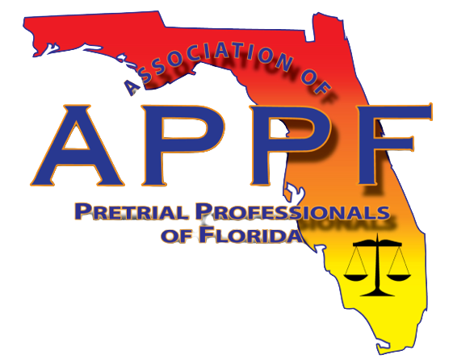

Ashley Baird

Role: APPF President

Agency: Alachua County

Summary:

Ashley is an Accreditation and Grants Manager with Alachua County in Gainesville, Florida. Ashley has previously served as the Vice President of APPF and as the NW Regional Director of APPF. Prior to her current position with Alachua County, Ashley was an Electronic Monitoring (EM) Officer and Pretrial Officer with the Alachua County Department of Court Services beginning in 2017. Ashley began her career in public safety with the Florida Department of Juvenile Justice as a Detention Screening Officer. She also served as Court Liaison and a Quality Improvement reviewer. She ended her career with the Department as a Senior Juvenile Probation Officer where she worked primarily with human trafficking and foster care youth.

Ashley is a Certified Public Manager (CPM) through Florida State University (FSU), serves as an assessor with the Florida Corrections Accreditation Commission (FCAC), serves as an examiner with The Sterling Council of Florida, and is a Certified Pretrial Service Professional through the National Association of Pretrial Services Agencies (NAPSA). Ashley earned a Bachelor of Arts in English at the University of Florida (UF) and a Master of Science in Criminology at FSU.

