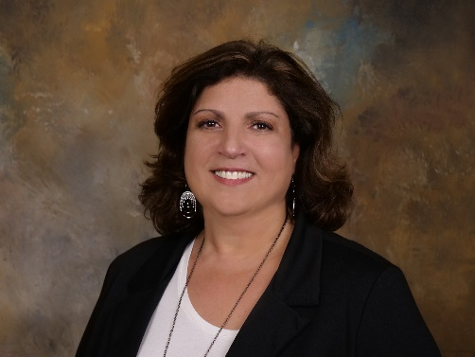
Katina Bouza

Role: President

Katina was born in Cuba and raised in New Jersey. She moved to Los Angeles after high school and lived there for five years. Katina then relocated to Naples, Florida and has been a member of the Collier County Sheriff’s Office since 1990. Katina currently holds the position of Corrections Support Division Director.

Katina earned a bachelor’s degree from Edison State College in Public Safety Administration with a minor in Criminal Justice Technology. She also earned a Master of Arts in Administration from Barry University. Katina has earned the distinction of Certified Jail Manager from the American Jail Association. She is a member of the National Association of Pretrial Service Agencies (NAPSA) and a Certified Pretrial Service Professional. Katina is also a 7 Habits of Highly Effective People facilitator.

Katina has served on the APPF Board as Treasurer, Sr. Board Member and is excited to be serving as your APPF President.

Katina is involved in many professional committees which include the Collier County Criminal Justice, Mental Health & Substance Abuse Planning Council, the Drug Exposed Newborn Committee, the Community Behavioral Health Committee and the Drug Free Collier Task Force.

