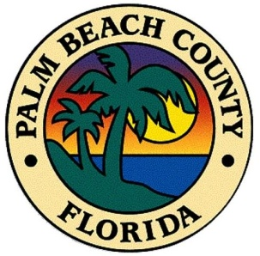



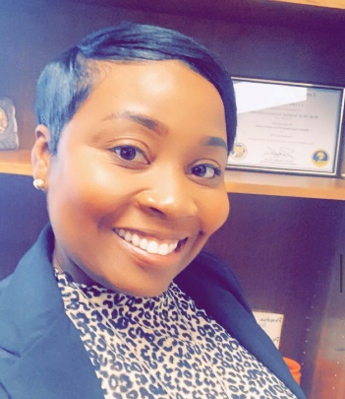

**Latronda Hayes**

Role: Social Media Coordinator

Agency: Palm Beach County Justice Services Division

Summary:

Latronda Hayes is the Court Services Manager for Palm Beach County Justice Services Division, which includes Pretrial Services, the Palm Beach County Supervised Release program, the Palm Beach County Community Services program and the Court Forensic Psychology program. Latronda is a native Floridian who began her career in Public Safety in 2001, working all facets of Pretrial Services prior to becoming the manager. As the Court Services Manager, Latronda is tasked with the direction and administration of major functional areas for the County funded Court programs. She also oversees the County’s contract with the Legal Aid Society of the Palm Beaches and is responsible for the fiscal management of the Drug Courts. She serves on several court related committees, including the Core Planning Team for Palm Beach County Criminal Justice Commission’s McArthur Safety and Justice Challenge Initiative.

Latronda holds a Bachelor’s Degree in Criminal Justice from Florida Atlantic University and a Master’s Degree in Public Administration from Nova Southeastern University. Latronda is a member of APPF, NAPSA and is a Certified Pretrial Services Professional through NAPSA since 2012. Latronda is currently the Social Media Coordinator for the Association of Pretrial Professionals of Florida.